Final EDA Report Content
1. Dataset Overview
The dataset contains customer financial information used to analyze the likelihood of loan delinquency. Key variables include customer income, credit score, credit utilization, loan balance, missed payments, and debt-to-income ratio. These attributes help identify behavioral and financial patterns that may influence delinquent loan accounts.

Step 1 — Key Insights from Dataset
Key Observations
- The dataset contains both delinquent and non-delinquent customers.
- Some columns initially had missing values, particularly income, credit score, and loan balance.
- Customers with higher missed payments and higher credit utilization appear more likely to become delinquent.
- Lower credit scores show a stronger relationship with delinquent accounts.
Key Anomalies
- Some credit utilization values were very high (>0.8) indicating potential financial stress.
- A few records had missing financial information, which could affect predictive modeling.
Early Risk Indicators
The following variables appear to influence delinquency:
- Missed Payments
- Credit Utilization
- Debt-to-Income Ratio

Data Quality Summary
The dataset was reviewed to understand its structure and identify potential quality issues. Several columns contained missing values, particularly income, credit score, and loan balance. These missing values were handled using median imputation to maintain data distribution and avoid bias. Some variables such as credit utilization and missed payments showed strong relationships with delinquency status. Overall, the dataset is suitable for further analysis and predictive modeling after cleaning.

Step 2 — Handling Missing Data
Column | Issue | Method Used | Justification
Income | Missing values | Median Imputation | Median prevents influence of extreme income values
Credit Score | Missing values | Average Imputation | Maintains realistic distribution of credit scores
Loan Balance | Missing values | Median Imputation | Avoids skew caused by large loan amounts

Step 3 — Key Risk Indicators
- Missed Payments
Customers with a higher number of missed payments show a significantly higher likelihood of delinquency.
- Credit Utilization
Higher credit utilization ratios indicate customers are using a large portion of their available credit, increasing financial risk.
- Debt-to-Income Ratio
Customers with higher debt relative to income show greater delinquency risk.
- Credit Score
Lower credit scores are strongly associated with delinquent accounts.
- Loan Balance
Higher loan balances slightly increase delinquency probability due to higher repayment pressure.

Key Insights from Visualization
- Delinquent customers represent a smaller portion of the dataset compared to non-delinquent customers.
- Customers with higher credit utilization and higher missed payments show increased delinquency risk.
- Lower credit score groups have higher delinquency rates.
- Customers with higher debt-to-income ratios show higher delinquency probability.

Ethical Considerations
Synthetic or imputed data must be used carefully to avoid introducing bias into the dataset. Generated values should follow realistic financial patterns and maintain the original distribution of the data. It is also important to ensure that synthetic data does not distort risk indicators or lead to misleading conclusions. All imputation techniques should align with industry standards and regulatory compliance to maintain fairness and transparency.

Final Conclusion
The exploratory data analysis identified several important variables that influence loan delinquency, including missed payments, credit utilization, credit score, and debt-to-income ratio. After cleaning and handling missing values, the dataset provides reliable insights into customer financial behavior. These findings will help Geldium refine its delinquency prediction models and improve early risk detection strategies.

Final Visualization

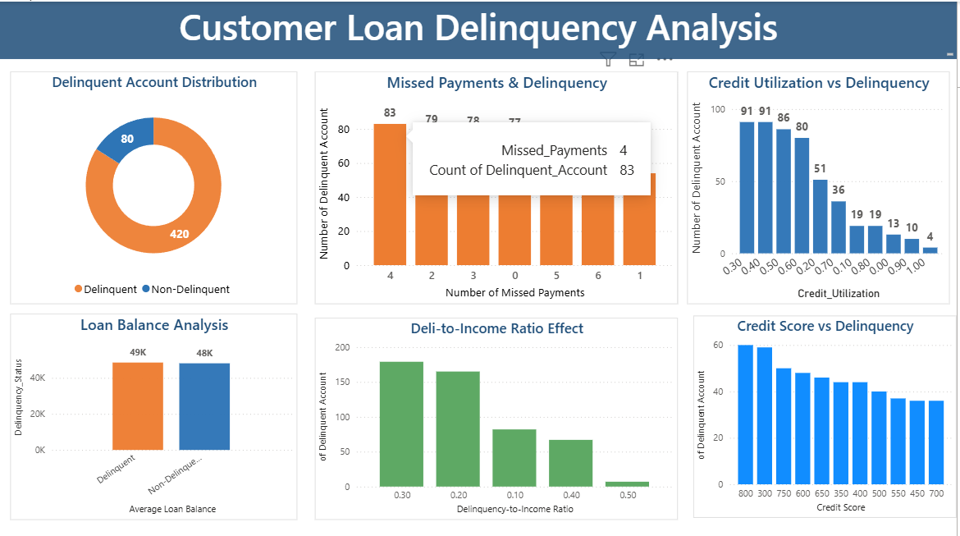

Final Conclusion
The exploratory data analysis identified several important variables that influence loan delinquency, including missed payments, credit utilization, credit score, and debt-to-income ratio. After cleaning and handling missing values, the dataset provides reliable insights into customer financial behavior. These findings will help Geldium refine its delinquency prediction models and improve early risk detection strategies.

